**SCULPTURE**

What is a sculpture? (1pt)   
___________________________________________________________________________

1. _______________

2. _______________

3. _______________

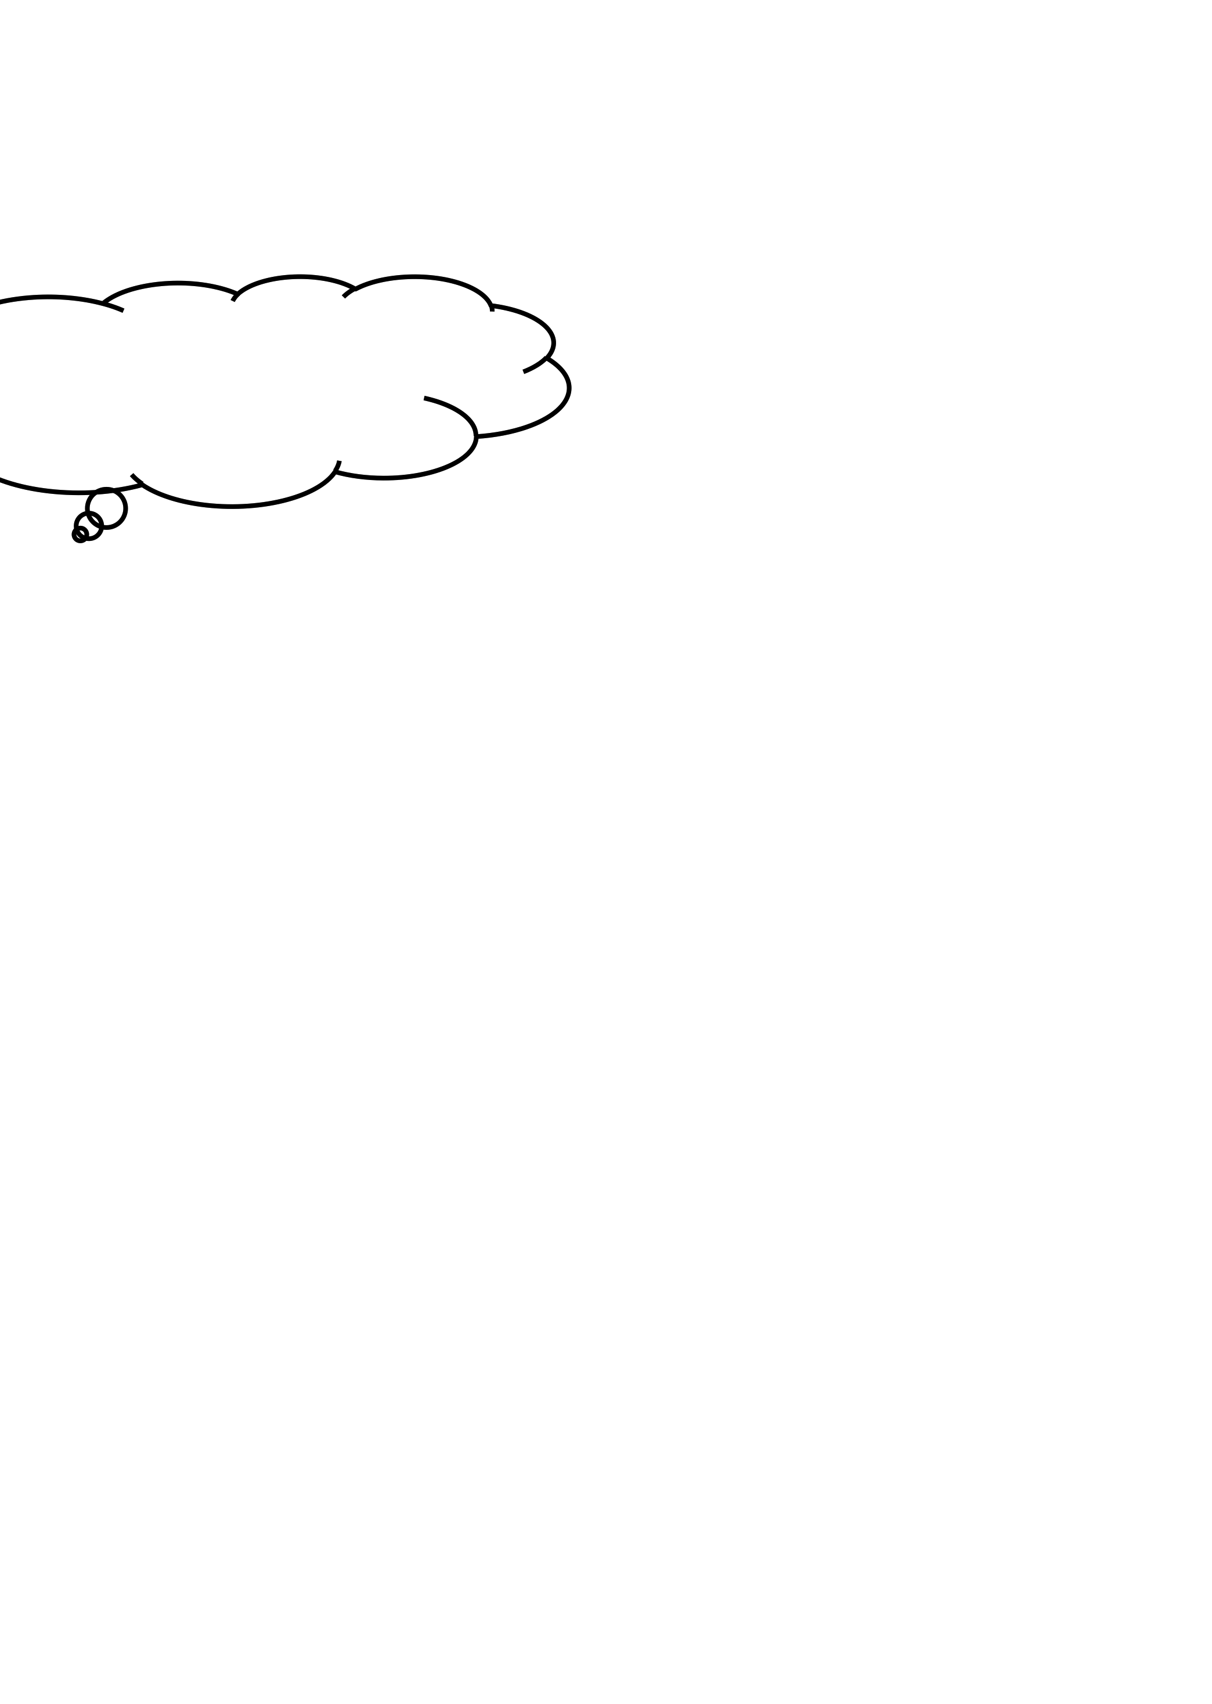

A sculptural technique where the sculpted elements remain attached to a solid background of the same material is called _________ sculpture. (1pt)

**DAY 1**

**DAY 2**

Name: _____________________ (1pt)

Section:____________________ (1pt)  
Date:_____/______/________ (1pt)

**Please DO now!**

(2pts)

(1pt)

(1pt)

(3pts)

Review day!!

**A**. In the Round **B**. Sculpture

**C.** Relief

An in-the-round sculpture is a free standing sculpture with _______ sides shown. (1pt)

1. _______________

2. _______________

3. _______________



**DAY 3**

**DAY 4**

* Artwork that stands up and can be measured in three ways, height, width, and depth. _____
* A sculptural technique where the sculpted elements remain attached to a solid background of the same material. ______
* A sculpture standing free with all sides shown.______

In-The-Round

Relief

How many dimensions are in 3D art? (1pt) _______  
Bonus! What are they?   
_____x______x_______

1. _______________

2. _______________

3. _______________



QUIZ DAY!

**DAY 7**

**DAY 8**

(3pts)

(1pt)

(1pt)

Which artist made sculptures of play doh and balloon animals representing childlike imagination?

_____ _______ (2pts)

1. _______________

2. _______________

3. _______________



What kind of sculpture are we creating in this project?   
______-_____-_________(1pt)

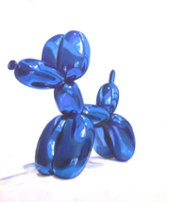

**DAY 5**

**DAY 6**

1. **Sculptur**e - ____________________________________________________  
______________________________________________________________.

2. **Relief** - ______________________________________________________  
______________________________________________________________.

3. **In-The-Round -** ________________________________________________  
______________________________________________________________.

20 POINTS!   
  
MAKE SURE TO REVIEW YOUR ANSWERS!

TOTAL POINTS

__ /20

____%

Name:_____________________ (1pt)  
Section:____________________ (1pt)  
Date:_____/______/________ (1pt)

**SCULPTURE: QUIZ**(same word can be used twice)

1. A sculpture is measured in what three ways? (3pts)  
   ___________ ___________ ____________
2. A sculpture standing free with all sides shown create a _________ sculpture. (1pt)
3. Subtractive sculpture is when an artist (1pt) ________________________________________
4. A sculptural technique where the sculpted elements remain attached to a solid background of the same material creates a ______ sculpture. (1pt)
5. What kind of sculpture did we create? (In the Round or a relief).  
   ___________________ (1pt)

1. In the series Zoom, which artist focuses with laser-beam intensity on the intimate features of everyday items and materials that are usually overlooked by the human eye? (2pts)  
     
    ________ _________
2. Which artist made sculptures of play doh and balloon animals representing childlike imagination? (2pts)  
     
   __________ __________
3. Which two artists create giant sculptures together, and have a high focus on their location, transforming the item to something new. (4pts)  
     
   ________ ________ and _______ ___ _______
4. Draw a relief sculpture Draw a in the round sculpture from the front. (2pts)

Relief In the Round

|  |  |
| --- | --- |
|  |  |

**WORD BANK**

Relief Subtractive Width

Additive Jeff Koons In the round

Length Height Rómulo Celdrán

Claes Oldenburg Coosje van Bruggen's

**WORD BANK**

Relief Subtractive Width

Additive Jeff Koons In the round

Length Height Rómulo Celdrán

Claes Oldenburg Coosje van Bruggen's

**WORD BANK**

Relief Subtractive Width

Additive Jeff Koons In the round

Length Height Rómulo Celdrán

Claes Oldenburg Coosje van Bruggen's